EXPERIMENT NO. 07

Implement Probability Experiments Using R

PART B

PART B: TO BE COMPLETED BY STUDENTS)
(Students must submit the soft copy as per following segments within two hours of the practical. The soft copy must be uploaded on the ERP or emailed to the concerned lab in charge faculties at the end of the practical in case the there is no ERP access available)
Roll No. CO-60 | Name: Avdhut Parish Madhavi
Class : SE-C | Batch : C2
Date of Experiment: | Date of Submission
Grade :

Observation: (Run the programs given above in R studio and paste screenshots of along with the output)

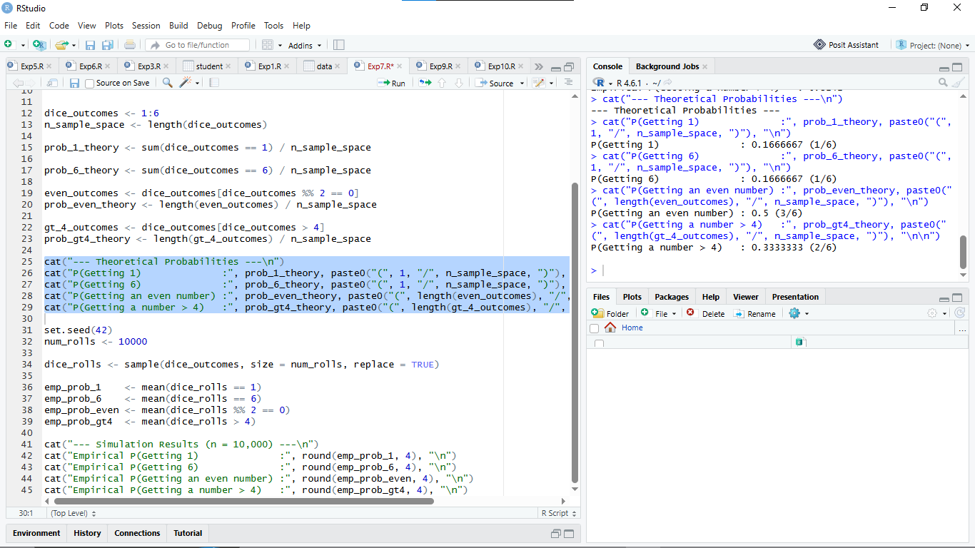

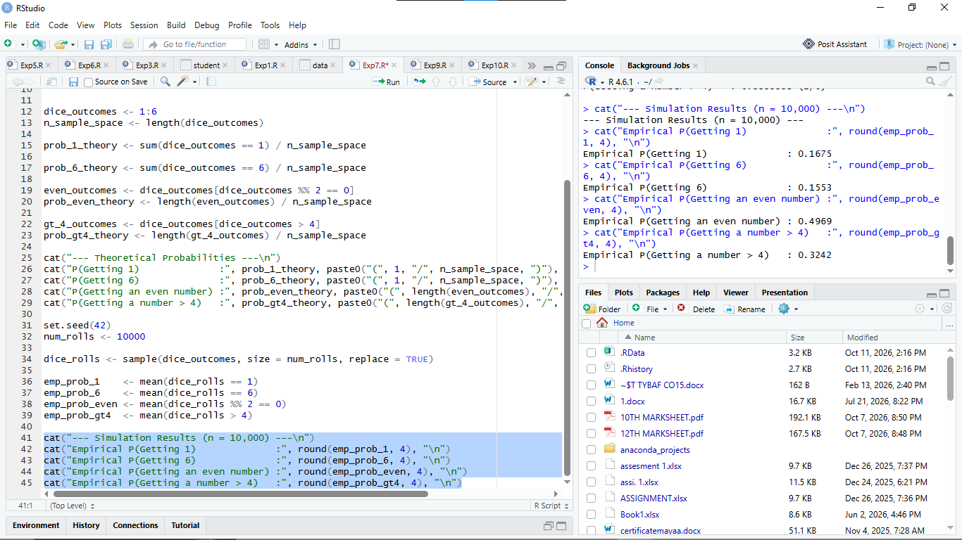

Observation Table:
Sr. No. | Experiment / Event | R Function / Syntax Used | Theoretical Probability | Experimental Probability (n=10,000)
1 | Coin Toss: Getting a Head | mean(tosses == "Head") | $0.5000\ (1/2)$ | $\approx 0.5029$
2 | Coin Toss: Getting a Tail | mean(tosses == "Tail") | $0.5000\ (1/2)$ | $\approx 0.4971$
3 | Dice Roll: Obtaining 1 | mean(dice_rolls == 1) | $0.1667\ (1/6)$ | $0.1675$
4 | Dice Roll: Obtaining 6 | mean(dice_rolls == 6) | $0.1667\ (1/6)$ | $\approx 0.1681$
5 | Dice Roll: Getting an Even Number | mean(dice_rolls %% 2 == 0) | $0.5000\ (3/6)$ | $\approx 0.5014$
6 | Dice Roll: Getting a Number $> 4$ | mean(dice_rolls > 4) | $0.3333\ (2/6)$ | $\approx 0.3347$

Result:
Basic probability experiments for coin tossing and dice rolling were successfully implemented in R using computational simulation techniques via the sample() function. The empirical relative frequencies obtained over $10,000$ trials closely matched their respective mathematical theoretical values, validating the Law of Large Numbers.

Curiosity Questions:
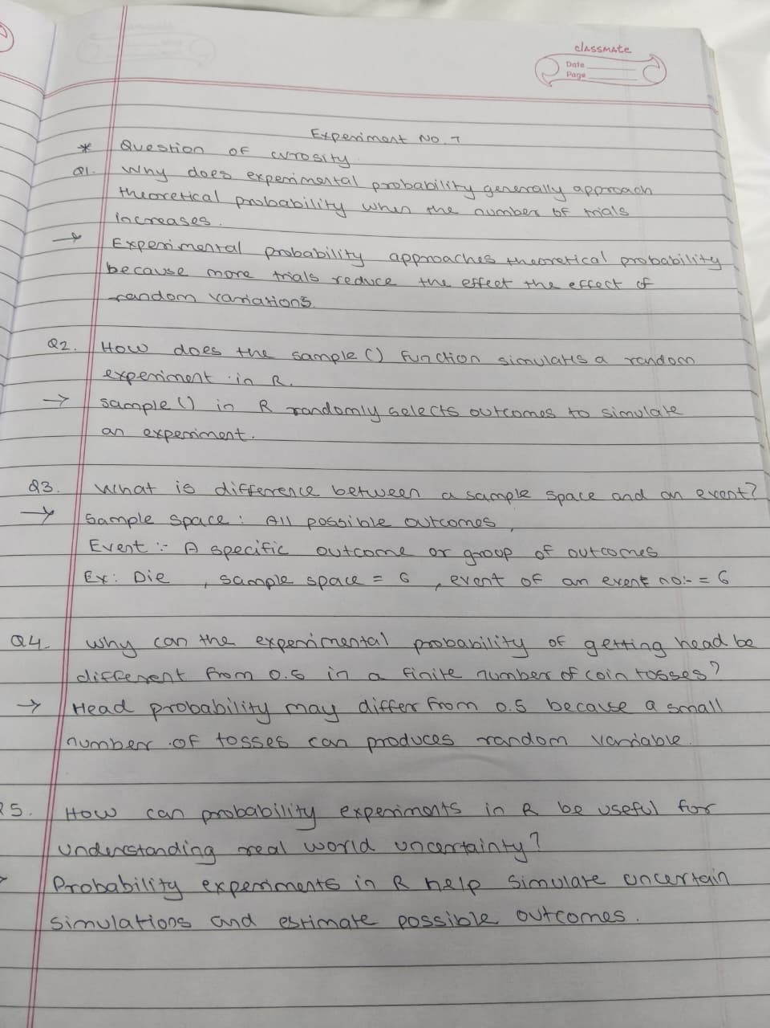
Viva voce Questions:
1. What is probability, and what is its possible range?
Probability is the measure of the likelihood of an event occurring. Its range is from 0 to 1, where 0 represents an impossible event and 1 represents a certain event.
Formula: 0 ≤ P(E) ≤ 1
2. What is a random experiment? Give two examples.
A random experiment is an experiment whose exact outcome cannot be predicted in advance.
Examples:
- Tossing a coin.
- Rolling a die.
3. What is a sample space? Write the sample space for a coin toss.
A sample space is the set of all possible outcomes of a random experiment.
For a coin toss: S = , where H represents Head and T represents Tail.
4. What is an event? Give an example for a die-rolling experiment.
An event is a subset of the sample space consisting of one or more outcomes of a random experiment.
Example: Getting an even number when rolling a die.
E = 6
5. Differentiate between theoretical probability and experimental probability.
Theoretical Probability:
- It is based on all possible outcomes.
- It is calculated mathematically.
- Example: The probability of getting a head on a fair coin is 1/2.
Experimental Probability:
- It is based on actual observations.
- It is calculated by performing experiments.
- Example: If 6 heads occur in 10 tosses, the experimental probability is 6/10 = 0.6.
6. Which R function is used to generate random samples?
The sample() function is used to generate random samples from a given set of values.
Example:
sample(1:6, 5, replace = TRUE)
This generates five random numbers from 1 to 6.
7. How is the sample() function used to simulate coin tossing?
The sample() function randomly selects either Head or Tail to simulate coin tossing.
R Code:
sample(c("H", "T"), 10, replace = TRUE)
This simulates 10 coin tosses.
8. How can sum() be used to count the occurrence of an event in R?
The sum() function counts the occurrences of an event by adding TRUE values returned by a logical condition.
R Code:
x <- c(2, 4, 3, 6, 1)
sum(x %% 2 == 0)
Output: 3
Explanation: Three numbers (2, 4, and 6) are even.
9. How can mean() be used to calculate experimental probability in R?
The mean() function calculates experimental probability by finding the average of logical values, where TRUE = 1 and FALSE = 0.
R Code:
x <- c(2, 4, 3, 6, 1)
mean(x %% 2 == 0)
Output: 0.6
Explanation: The experimental probability of getting an even number is 3/5 = 0.6.
10. What is the theoretical probability of getting an even number when a fair die is rolled?
The even outcomes are 6.
Formula:
P(E) = Favourable Outcomes / Total Outcomes
P(E) = 3/6 = 0.5
Answer: 0.5 or 50%.
11. What is the theoretical probability of getting a number greater than 4 on a fair die?
The favourable outcomes are 6.
Formula:
P(E) = Favourable Outcomes / Total Outcomes
P(E) = 2/6 = 1/3
Answer: 1/3 or approximately 0.3333.
12. Why does experimental probability tend to become closer to theoretical probability as the number of trials increases?
According to the Law of Large Numbers, as the number of independent trials increases, the experimental probability tends to approach the theoretical probability.
13. What is the purpose of set.seed() in R?
The set.seed() function ensures the reproducibility of random results. Using the same seed and code produces the same sequence of random values.
R Code:
set.seed(123)
sample(1:6, 5, replace = TRUE)
14. What is the role of replace = TRUE in the sample() function?
The argument replace = TRUE allows an element to be selected more than once.
R Code:
sample(1:6, 10, replace = TRUE)
This generates 10 random numbers from 1 to 6, allowing repetitions, as in repeated die rolls.
15. How can R be used to compare theoretical and experimental probabilities?
R can simulate random experiments, calculate experimental probability using mean(), and compare it with theoretical probability.
R Code:
set.seed(123)

rolls <- sample(1:6, 1000, replace = TRUE)

theoretical <- 3/6
experimental <- mean(rolls %% 2 == 0)

print(theoretical)
print(experimental)
Explanation: The theoretical probability of getting an even number is 0.5. The experimental probability is calculated from 1,000 simulated die rolls and will generally be close to 0.5.

